Cheryl Waters, GRI
Visit My Web Site: www.cherylwaters.ebby.com
Facebook page: www.facebook.com/CherylWatersRealtor

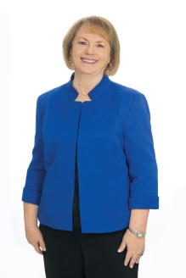
Coming from a background in various aspects of the legal and real estate fields, I am committed to the philosophy that the only thing I really have to sell to my clients is the highest level of service. I will assist you every step of the way in navigating the sometimes "rough waters" of a real estate transaction, whether you are a buyer or seller. My hope is to make the buying or selling process smooth sailing for you and earn the future referral of your friends and family. Call on my expertise to guide you through your next home, land, or commercial sale/purchase in the North Texas area.
Experience/Awards:
- Licensed Realtor since 1980 - 17 years in real estate sales, including 7 years specializing in farm/ranch & rural residential (primarily in Fannin County)
- 2 years commercial/retail property management
- 10 years as a legal assistant (2 years for real estate attorneys)
- 3 years as Assistant Escrow Officer for a title company
- First Place, Most Outbound Referrals Closed – 2014
- Top Producer, Ebby Halliday Realtors-Sherman
- Multi-Million-Dollar Producer
- GRI Designation (Graduate, Realtor Institute)
Member:
- Greater Texoma Associations of Realtors, Texas Association of Realtors, and National Association of Realtors
- Past Historian & Registrar – Martha Jefferson Randolph Chapter of The Daughters of the American Revolution
- Denison Genealogical Association
Mobile: 903-449-1156 e-mail: cherylwaters@ebby.com

S H E R M A N O F F I C E
3445 FM 1417 N., Sherman, Texas 75092 – Office 903-893-5921 – E-Fax 903-771-5166

